Digital to Physical report

1 Introduction

The team chose the game “Fall Guys” to develop into a board game using the board game snakes and ladders as inspiration.

2 Rules and Mechanics, How the Game Works

The players roll a die to be able to move further on the board.

There are certain squares that the player can land on that will affect their game. Those being chance card squares and trivia card squares.

When landing on a chance square they move back. The player must pick up a card which will then tell them how many squares they’ve been moved back.

Trivia questions move the player forward if answered correctly. The number of spaces forward depends on the difficulty of the question.

The goal of every player is to be the first person to reach the finish square.

Figure 1 the board that the team created using an online whiteboard

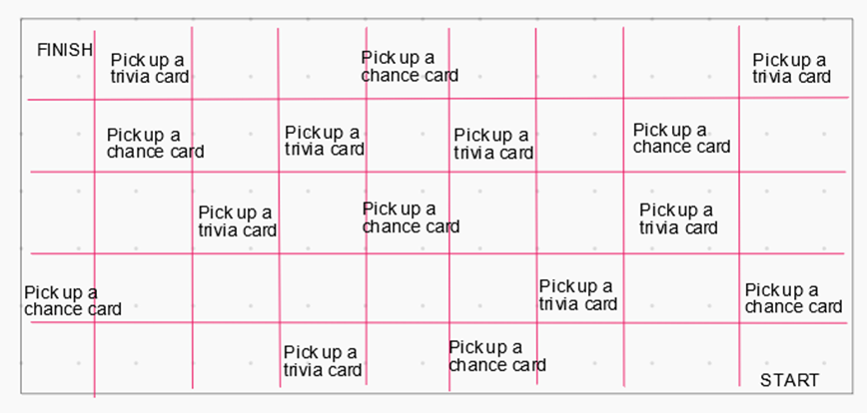

Figure 2 an example of the chance cards

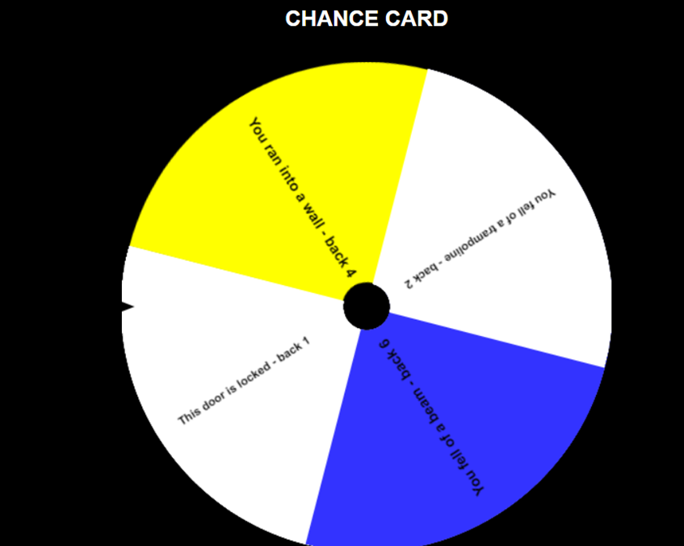

Figure 3 example of the trivia questions

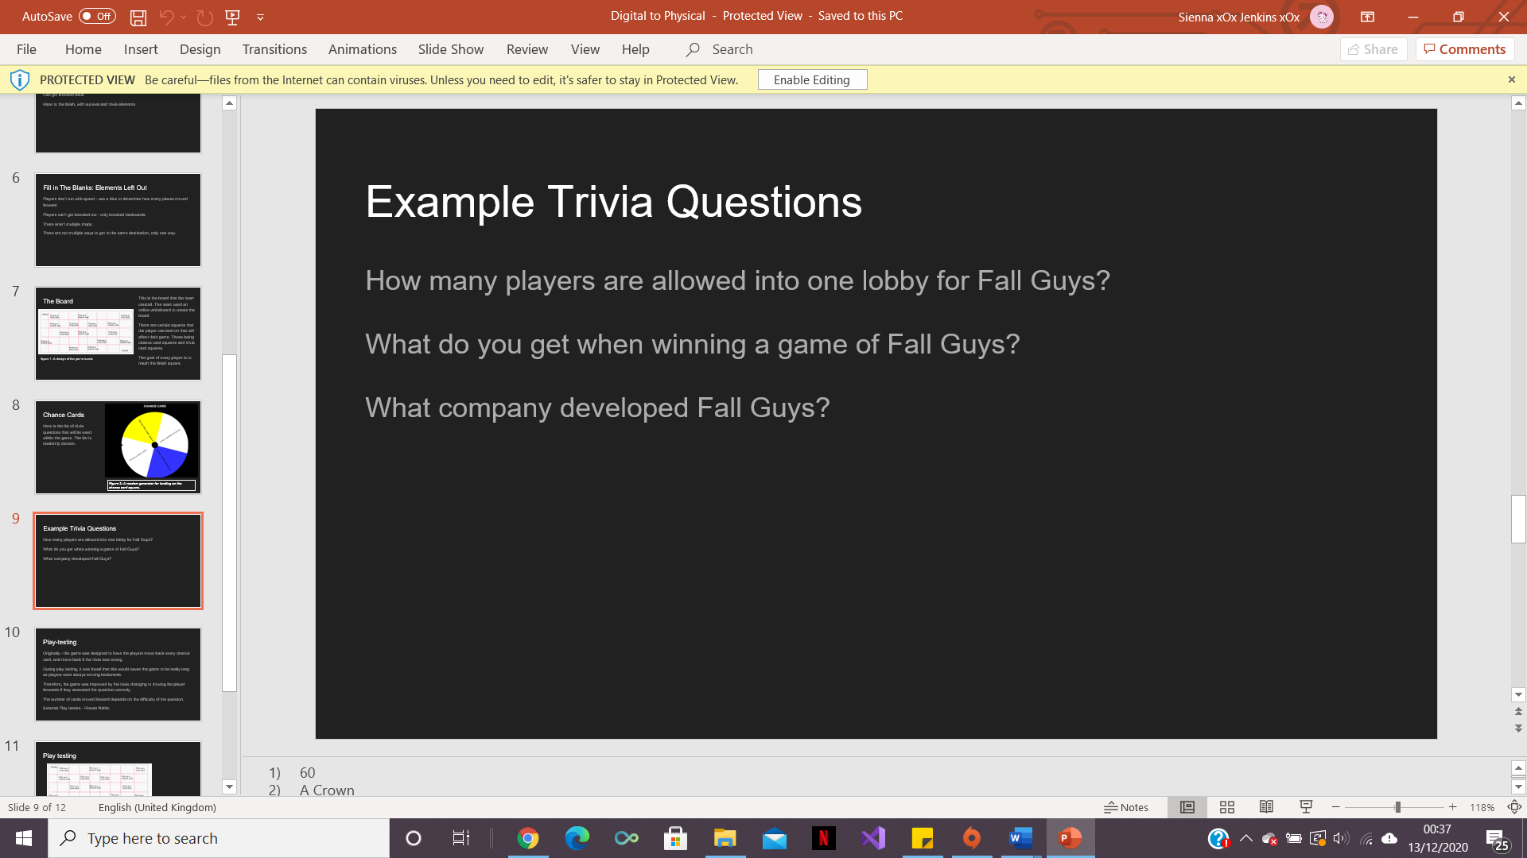

3 Play Testing

Originally - the game was designed to have the players move back every chance card and then also move back if the trivia was wrong.

During play testing, it was found that this would cause the game to be incredibly long as players would always be moving backwards.

Therefore, the game was improved by changing the trivia card to move the player forwards if they were to answer question correctly.

The number of squares moved forward depends on the difficulty of the question.

4 Working in a Team

Working in a team was good and productive. Everyone shared ideas and different team members could complete different parts of the task at the same time to complete it quicker.

This helped with time management and task completion in the limited amount of time that was available.

Everyone in the team got on well and this made the task run smoothly.

One thing that would’ve been good to improve would be better time management as the completion of the task was cut fine as the team spent too long on some areas and not enough time on other areas.

Members of the Team:

Akash Sroay,

Sienna Jenkins

And Joshua Baker.

Play testers:

Rowan Noble